Address Calculation in 1D, 2D, 3D, and nD Arrays in Row-Major and Column-Major Order
When working with arrays in programming, data is stored in contiguous memory locations. The address of an element in an array can be computed using address calculation formulas, depending on whether the array is stored in row-major or column-major order.

1. Address Calculation for a 1D Array
A one-dimensional array (1D array) is the simplest form of an array.
General Formula
If Base Address = B (starting memory location of the array) and size of each element = W, then for an array A[L], the address of element A[i] is:
Address(A[i])=B+(i×W)
Example
Consider an integer array A[5] stored starting at memory location B = 1000, with W = 4 bytes (for integer data type).
Address(A[i])=1000+(i×4)
Index i | Address (A[i])
0 | 1000
1 | 1004
2 | 1008
3 | 1012
4 | 1016

2. Address Calculation for a 2D Array
A two-dimensional array is stored either in row-major order or column-major order.
Row-Major Order (C-style)
Elements are stored row-wise in memory.
Formula:
For a 2D array A[M][N], the address of an element A[i][j] is:
Address(A[i][j])=B+[(i×N)+j]×W
Example:
Consider a 3 × 4 matrix A[3][4] with B = 2000, W = 4 bytes.
A = | A[0][0] A[0][1] A[0][2] A[0][3] |
| A[1][0] A[1][1] A[1][2] A[1][3] |
| A[2][0] A[2][1] A[2][2] A[2][3] |
Finding Address of A[2][1]:
Address(A[2][1])=2000+[(2×4)+1]×4
=2000+[8+1]×4
=2000+36
=2036

Column-Major Order (Fortran-style)
Elements are stored column-wise in memory.
Formula:
Address(A[i][j])=B+[(j×M)+i]×W
Example:
Using the same A[3][4] matrix with B = 2000, W = 4 bytes.
Finding Address of A[2][1]:
Address(A[2][1])=2000+[(1×3)+2]×4
=2000+[3+2]×4
=2000+20
=2020

3. Address Calculation for an nD Array
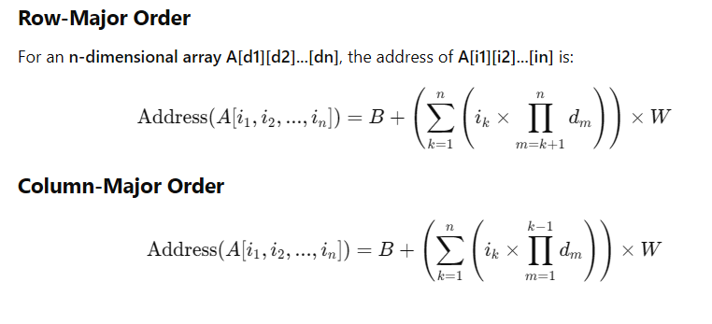
Conclusion
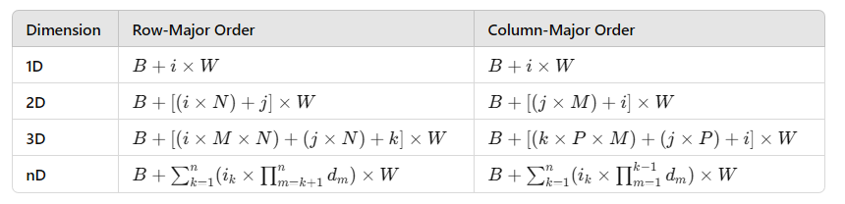
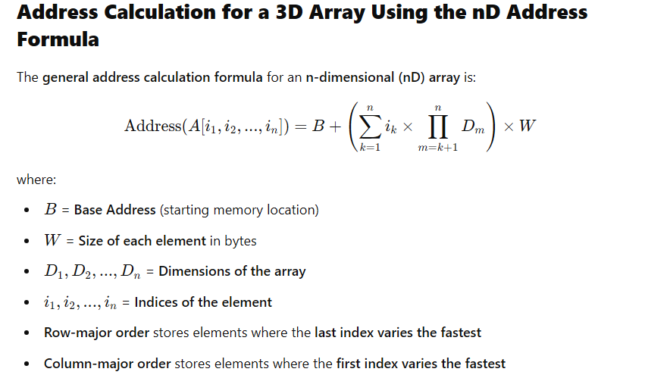
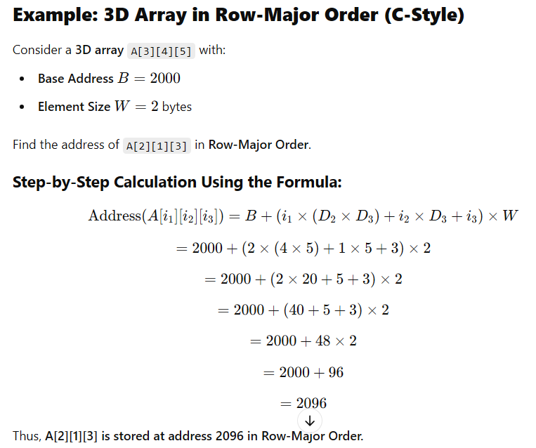
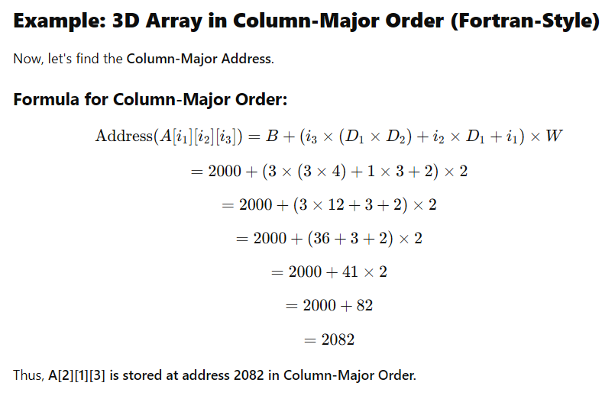
Formula for a 3D array
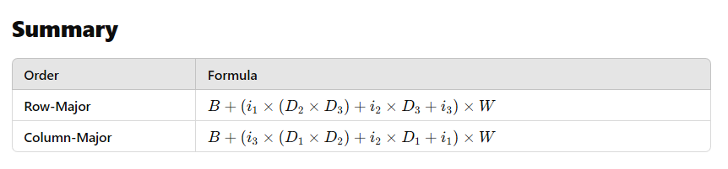
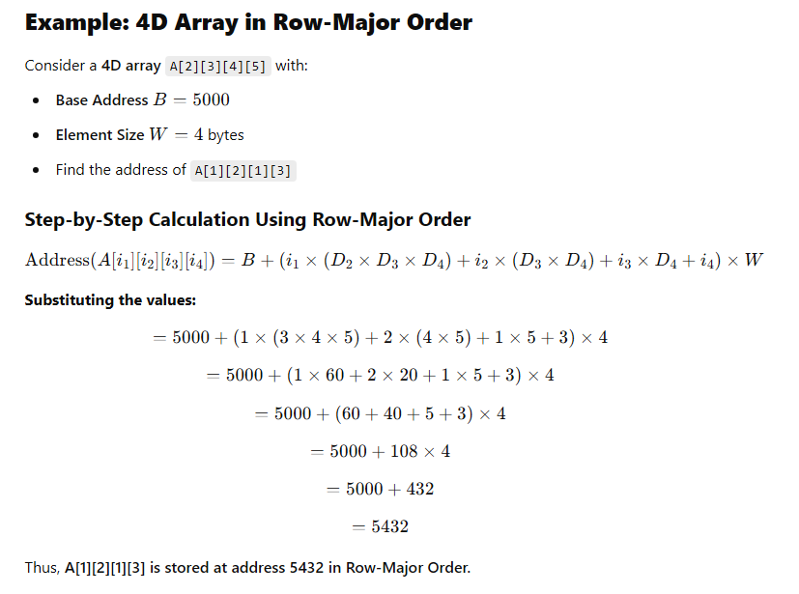
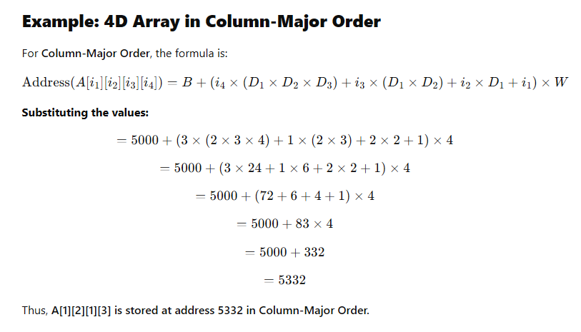

Formula for a 3D array

Formula for a 4D array
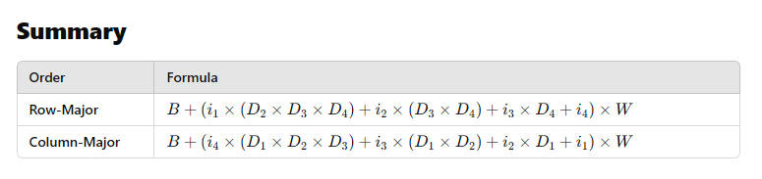
Formula for a 5D array
